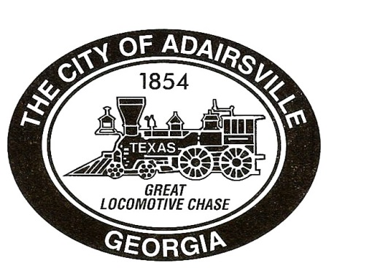
City of Adairsville
Council Meeting
February 11, 2021
7:00 P.M.
Agenda

- Invocation/Pledge

- Call to Order

- Approve Agenda

- Citizens wishing to speak

Agenda Item # 1:
MOTION TO ADOPT MINUTES
- MOTION TO ADOPT January 11, 2021 Organizational Meeting
- MOTION TO ADOPT January 12, 2021 Work Session
- MOTION TO ADOPT January 14, 2021 Council Meeting

Agenda Item # 2:
- MOTION TO APPROVE the reappointment of Jeanita Strain to the Unified Zoning Board for a three-year term ending February 12, 2024 as nominated by Mayor Pro Tem Lee Castro.

- MOTION TO APPROVE the reappointment of Gregory Harris to the Unified Zoning Board for a three-year term ending March 8, 2024 as nominated by Mayor Kenneth Carson.

- MOTION TO APPROVE the reappointment of Cindy Wade to the Downtown Development Authority for a three-year term ending February 12, 2024 as nominated by Councilmember Alan Towe.

Agenda Item # 3:
MOTION TO APPROVE Agreement with NextSite LLC for Retail Consulting Services for 2021 in the amount of $7,500.00.

Agenda Item # 4:
2nd Reading
MOTION TO APPROVE Ordinance #2021-CD-001 rezoning Parcel #A010-0171-001 from IND-G (General Industrial) to C-2 (General Business) with conditions and directing staff to amend the Official Zoning Map.

Agenda Item # 5:
2nd Reading
MOTION TO APPROVE Ordinance #2021-CD-002 rezoning Parcel #A010-0171-002 from IND-G (General Industrial) to C-2 (General Business) with conditions and directing staff to amend the Official Zoning Map.

Agenda Item # 6:
2nd Reading
MOTION TO APPROVE Ordinance #2021-CD-003 rezoning Parcel #A010-0171-004 from IND-G (General Industrial) to C-2 (General Business) with conditions and directing staff to amend the Official Zoning Map.

Agenda Item # 7:
2nd Reading
MOTION TO APPROVE Ordinance #2021-CD-004 rezoning Parcel # A010-0160-002 from IND-G (General Industrial) to C-2 (General Business) with conditions and directing staff to amend the Official Zoning Map.

Agenda Item # 8:
2nd Reading
MOTION TO APPROVE Ordinance #2021-CD-005 rezoning Parcel #A010-0171-007 from IND-G (General Industrial) to C-2 (General Business) with conditions and directing staff to amend the Official Zoning Map.

Agenda Item # 9:
2nd Reading
MOTION TO CONSIDER Ordinance #2021-0001- approving a text amendment for changes to Chapter 47 (Zoning) of the Adairsville Code.

Open Public Hearing
Agenda Item # 10:
1st Reading and Public Hearing
MOTION TO CONSIDER Ordinance #2021- 0002 approving a text amendment to Chapter 47 of the Adairsville Code of Ordinances to allow for auto sales in IND-G (Industrial G) through a special use permit.
- Staff Report
- Community Development Staff
- Applicant comments
Citizens Wishing to Speak

Close Public Hearing

Open Public Hearing
Agenda Item # 11:
1st Reading & Public Hearing
MOTION TO CONSIDER Ordinance #2021-CD-006 approving a special use permit for parcel #A002-0009-022, and direct staff to amend the Official Zoning Map.
- Staff Report
- Community Development Staff
- Applicant comments
Citizens Wishing to Speak

Close Public Hearing

Open Public Hearing
Agenda Item # 12:
1st Reading & Public Hearing
MOTION TO CONSIDER Ordinance #2021-CD-007 rezoning Parcel #A009-0198-002 from R-2 (Residential) to MF (Multi-Family) and directing staff to amend the Official Zoning Map.

- Staff Report
- Community Development Staff
- Applicant comments
Citizens Wishing to Speak

Close Public Hearing

- Adjourn

