THE CITY OF ADAIRSVILLE
116 PUBLIC SQUARE
ADAIRSVILLE GA 30103

The City of Adairsville is seeking proposals for sign creation, masonry work, and installation of five (5) new monument-style welcome signs in the City limits of Adairsville.

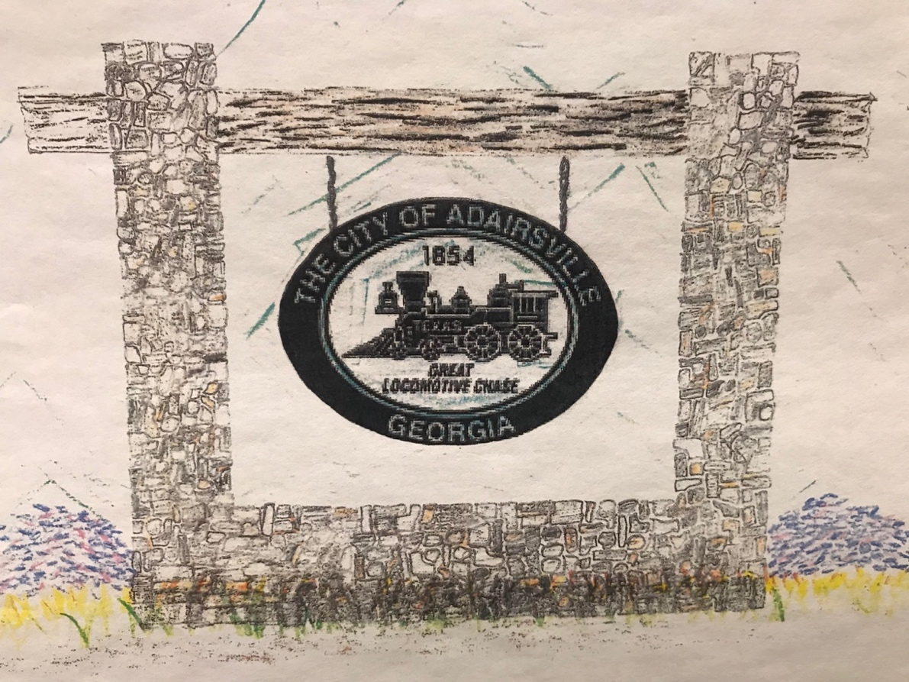
WELCOME

Scope of Work:
- Smaller signs (2): stacked stone base approximately 2 ft height with stacked stone columns approximately 7 ft height, 8 ft length. Pressure treated wood approximately 9-inch height, approximately 10 ft length. “WELCOME” letters font Dutch801 XBd BT mounted on wood approximately 9-inch height. Oval sign one-sided to be High Density Urethane (HDU) material, approximately 3 ft height, 4 ft length hanging on galvanized chain. Solar projecting lights for visibility at night.
- Larger signs (3): stacked stone base approximately 2 ft height with stacked stone columns approximately 9 or 10 ft height, 10 or 11 ft length. Pressure treated wood approximately 1 ft height, approximately 12 or 13 ft length. “WELCOME” letters font Dutch801 XBd BT mounted on wood approximately 1 ft height. Oval sign one-sided to be HDU material, approximately 5 ft height, 6 ft length hanging on galvanized chain. Solar projecting lights for visibility at night.
- All work is to be performed starting no earlier than 7:00 am.
- Contractor shall furnish all labor, equipment, and materials necessary to complete the scope of work.
- Maintain General Liability Insurance ($1,000,000 minimum) and must furnish proof of such insurance.

Pricing:
- Include pricing for each sign for the following:
  - Sign
  - Timber and galvanized chain
  - Masonry
  - Solar projecting lights
  - Labor

The submittal must provide for all costs, services, fees and any other expenses including, but not limited to those services specified and recommended. The E-Verify Form must also be submitted with the sealed bid. Incomplete bids will be deemed nonresponsive.

Sealed proposals must be received by April 30, 2021, 12:00 p.m., with “RFP Welcome Signs” on the front of the envelope and delivered to:

City of Adairsville
116 Public Square
Adairsville, GA 30103
ATTN: Lisa Donald

Bid opening will be held on May 3, 2021, 9:30 a.m. at City Hall, 116 Public Square, Adairsville, GA 30103.

Please contact Brady Hammonds, Zoning Administrator, at 470-529-4008 with any questions.

