We l c o m e
To the City of Adairsville, Georgia
A Budding City ready with Old Fashioned, Southern Hospitality and Hometown Charm! We are delighted that you have chosen to make Adairsville your new home!!
The City of Adairsville Utility Billing Department Provides services in billing and payment, deposits and water taps. We are committed to providing superior service at each opportunity and we strive to be accessible to our customers. Below is the information to contact us.
Monday - Friday from 8:00 a.m. through 5:00 p.m.
Stephanie Witt  Utility Office Manager  P: 770-773-3451 x 103  switt@adairsvillega.net | 116 Public Square  Adairsville, Georgia  770-773-3451  F: 770-773-2582  www.adairsvillega.net | Jennifer Willoughby  Customer Service  P: 770-773-3451 x 101  jwilloughby@adairsvillega.net
Here are a few important numbers you may need…….

Adairsville Code Enforcement/Code violations (Jason Stargell) 770-773-3451 x 108
Adairsville Depot (Historic Center) 770-773-1775
Adairsville Elementary School 770-606-5840
Adairsville High School 770-606-5841
Adairsville Library 770-769-9200
Adairsville Middle School 770-606-5842
Adairsville Police Department 770-773-7711
Adairsville Post Office 770-773-3848
Animal Control 770-387-5153
D.N.R. (Wild Animals) 706-295-6041
Bartow Co. Clerk of Superior Court/Tax Assessor 770-387-5025
Bartow Co. Sheriff’s Department 770-382-5050
Bartow Co. Voter’s Registration 770-387-5098
Bartow Landfill & Recycling (Monday, Friday & Saturday) 770-387-5145
Burn Permits (City limits – 770-877-9021) (County – 770-387-3750)
Emergency 911
Fines/Citations (Paula Fouts) 770-773-3451 x 102
Garbage Service: Allied Waste 1-888-235-8503
Georgia Power 1-888-660-5890
North Bartow Community Services (Community Outreach) 770-773-3812
Tallatoona Community Action Partners (Energy Assistance) 770-817-4666

Starting Services

To obtain utility services, customers must personally come to the utility billing office to fill out a service request application. You will need to bring the following to our office:
For new customers from out of State or Town please call our office at (770) 773-3451 x 101.
Or
Email: Stephanie Witt switt@adairsvillega.net

- Driver’s license (picture ID)
- Lease or purchase agreement
- Residential security deposit for Water-----$100.00 Gas-----$200.00

The deposits are required at the time of application to establish service. Please make your check payable to The City of Adairsville. The deposits do not bear interest and will be deposited into the general fund account of the City of Adairsville. Gas deposits will be refunded to all customers who have received utility service at the same location for a period of twenty-four months and who has paid monthly utility bills promptly and regularly, and is not, at the end of the stated period, delinquent in the payments of the utility bills.

Payment Methods

Cash - Check - Money Order - Debit - Credit Cards
The City of Adairsville has established several ways to conveniently pay your bill:
- City Hall – Personally bring in your payment to The City of Adairsville Utility Billing Department located at 116 Public Square.

- Mail In Payments - The City of Adairsville will also accept payments through the mail. Please use envelope provided with utility bill or mail to:
City of Adairsville Utility Department
116 Public Square
Adairsville, Georgia 30103

- United Community Bank – United Community Bank located at 7400 Adairsville Highway accepts payments; must have current utility bill and full payment.

- 24- Hour Drop Box – Drop off your payment and ticket into our drop box located on the right side of City Hall at 116 Public Square.

- Debit, Credit Card –Debit and credit cards accepted

- Online Credit Card Payments –www.adairsvillega.net – Go to Pay Utilities Online
Enter your account number including the dashes to view balance

Returned Checks

It is the City’s policy to terminate service without notice in response to all returned checks.
There is a thirty-five dollar ($35.00) service charge, also fifty ($50.00) re-connect fee for all returned checks. To restore service from disconnection the full balance due, thirty-five-dollars ($35.00) service charge and fifty-dollar ($50.00) re-connect charge must be paid with cash or money order.

Payment of Utility Bills
All utility bills are generated the last business week of the month and mailed approximately the first of each month. Payments are due ON or BEFORE the 15th of each month. YOU WILL RECEIVE YOUR FIRST BILL by the first week of -___________________ Payments received after 5:00p.m. on the 15th of each month will be subject to a 10% penalty of the delinquent account. Accounts that have a past due balance are subject for disconnection without additional notice. Failure to receive bill or notices does not excuse payment of bill. If you do not receive your bill within the first five days the month you are scheduled to receive it, please contact City Hall or your local post office. You are responsible for paying your bills on time and in full. If you are unable to pay for your utility services, you are responsible for contacting the utility office immediately to determine if alternate payment arrangements can be made.
The City of Adairsville can disconnect services under the following conditions:
- Nonpayment of utility bill
- Upon Customer request (Must complete disconnection form at City Hall)
- Returned checks
- A dangerous or life-threatening situation exists
- A court has ordered the disconnection
- Non-compliance of planned payment agreement
- The utility detects fraudulent or unauthorized service use (and has reasonable grounds to believe the customer is responsible)
- $150.00 tampering fee for each meter plus cost of materials will be charged.
- Deposit will be increased
- Equipment has been tampered with (and the utility has reasonable grounds to believe the customer is responsible)
- The utility's equipment is being used in a way that disrupts service to other customers.
- By order of the Georgia Public Service Commission, any Court, or any other authorized public agency.
- Violation of applicable utility rules and regulations approved by and filed with the Georgia Public Service Commission.
Service disconnections for non-payments of bills will be restored same day only after entire bill plus a re-connection fee of $50.00. for each meter disconnected are PAID IN FULL. If the customer’s meter or meters remains off & locked for 10 days with no contact to the City of Adairsville, the customer’s account will be finalized and the deposits will be applied to the account. Should the customer wish to restore service after account has been finalized, a deposit will be required plus payment of any outstanding balance. The deposits may be increased.
Discontinuance of Service

If you plan to move from this location or wish to terminate your service, it is your responsibility to notify the City of Adairsville Utility Department at least three (3) days before the date that you wish to terminate service. All disconnection requests must be in writing by letter, email or on or Disconnection form provided at City Hall. Your service will be terminated and your meter will be read on that day requested. A final bill will be generated and sent to you during the next billing cycle. The deposits will be applied to the final bill. Please provide the Utility Department with a forwarding address and phone number so that the final bill and/or refund will be mailed to the proper person. Only person permitted to sign discontinuance of Service is Primary applicant on original application.

Effective January 1, 2019

Water Rates (Residential inside City limits)

Base Rate $6.90
Charge per 1,000 gallons
Tier 1 $3.28 (0 – 5,000 gallons)
Tier 2 $4.14 (5,001 – 10,000 gallons)
Tier 3 $6.57 (10,001 – gallons and up)
Sewer $3.28 (all)

Water Rates (Residential outside City limits)

Base Rate $12.00
Charge per 1,000 gallons
Tier 1 $4.29 (0 – 5,000 gallons)
Tier 2 $5.35 (5,001 – 10,000 gallons)
Tier 3 $8.59 (10,001 – gallons and up)
Sewer $4.29 (all)

Gas Rates (Residential Inside and outside City limits)

City of Adairsville Gas
Rates fluctuate monthly

ALL FEES AND RATES ARE SUBJECT TO CHANGE

10 Indoor Water conservation tips
- There are a number of ways to save water, and they all start with you.

- When washing dishes by hand, don’t let the water run. Fill one basin with wash water and the other with rinse water

- Dishwashers typically use less water than washing dishes by hand. Now, Energy Star dishwashers save even more water and energy.

- If your dishwasher is new, cut back on rinsing. Newer models clean more thoroughly than older ones.

- Designate one glass for your drinking water each day, or refill a water bottle. This will cut down on the number of glasses to wash.

- Soak pots and pans instead of letting the water run while you scrape them clean.

- Use the garbage disposal sparingly. Instead, compost vegetable food waste and save gallons every time.

- Wash your fruits and vegetables in a pan of water instead of running water from the tap.

- Don’t use running water to thaw food. For water efficiency and food safety, defrost food in the refrigerator.

- Install an instant water heater near your kitchen sink so you don’t have to run the water while it heats up. This also reduces energy costs.

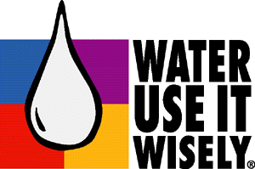

www.wateruseitwisely.com (for more water conservation tips)

Customer Copy of Gas Service application completed and initialed
The City of Adairsville is committed to providing safe, reliable natural gas service. We will maintain our gas lines in accordance with U.S. Department of Transportation and Georgia Public Service Commission Pipeline Safety Regulations. As a natural gas pipeline operator, the City of Adairsville is required by Federal Law to notify all customers of the following:
- Customer-owned, buried natural gas piping should be inspected periodically for leaks and, if the piping is metallic, also for corrosion. Examples of this piping are any buried piping from the gas service delivery location to your house or appliances or from the house to a swimming pool heater or a spa. If any gas leaks or evidence of corrosion to metallic piping are found, you should take immediate steps to correct it.

- Before doing any digging or have the utilities located in advance by calling 811. Contact a certified plumbing contractor in your area to help you locate and inspect your buried gas piping. If you have any questions about this notice, call the City of Adairsville at (770) 773-3451 x 112.
In consideration for granting a connection to the Natural Gas System of the City of Adairsville, I hereby agree to the following:
- I have read and understand this application, and agree to abide by the rules and regulations of the City of Adairsville Natural gas utility, as they may be revised from time to time.

- To allow the City of Adairsville to enter the property (with equipment if necessary), for the purpose of installing and/or maintaining the service line to up to and including the meter and, if applicable, the attached main line whether new or existing, from ingress to egress points on the property. It is understood that any disturbed areas will be repaired to as close as reasonable possible.
NOTICE:
- This is an application only and does not assure you of gas service.
- Customers gas appliances, lines and other equipment shall be installed by a Georgia State Licensed and bonded gas plumber.
- Installation shall be in accordance with the SBBCI standard gas code in effect at the time of installation, including all amendments as approved by the Department of Community Affairs, State of Georgia and The City of Adairsville. It shall be your responsibility, if required, to obtain a building permit and schedule the required inspections.
NOTE:
In this notice “customer” refers to the owner of the gas piping system served by The City of Adairsville. This may be either the property owner or another party that owns the gas piping.

City of Adairsville Public Awareness Message

Natural gas, America’s most popular home heating fuel, is increasingly popular for use by homeowners, schools, businesses, factories and electric power-generation plants because it is efficient, clean, reliable and a relative bargain compared to alternative energy sources.
In our community, The City of Adairsville provides natural gas to more than 1600 customers through a network of underground distribution lines. Main gas lines, typically 2-inch in diameter, branch into household service lines which are typically half-inch to three-quarter-inch in diameter and buried 12- to 18-inches below the surface. The service lines end at each customer’s meter where gas is delivered.
To protect you and others in the community; federal and state government, along with your utility provider have made your safety a high priority. Any time you dig or move earth in any way, you are required to “Call Before You Dig” 48 hours before beginning any digging. When you call 811, they will contact utility owners who will locate all buried utility lines on your property, so you can safely dig and prevent a potentially hazardous condition. Failure to use the 811 system is a known cause of pipeline accidents. Calling before you dig can prevent a costly or even deadly mistake.
Natural gas is a colorless, odorless gas; however, a chemical that smells like rotten eggs is added to help detect a possible leak. Some of the signs of a gas leak include seeing bubbling water, hearing a hissing or blowing sound from a pipeline or appliance, dead or discolored vegetation in an otherwise green area, or dirt or dust blowing from the ground, or the smell of rotten eggs.
If you smell gas, or just think you might have a gas leak, leave the area immediately and call The City of Adairsville at 770-773-3451 or 911 from a neighboring home or business. Never turn on or off switches, open or close garage doors, use a flashlight or phone/cellphone in the presence of the gas smell, as these devices may be a source of ignition, causing an explosion.
Do your part to familiarize yourself and your family with these natural gas safety tips and continue to enjoy the value, comfort and benefits of America’s cleanest, most efficient energy source!
This message is brought to you by The City of Adairsville as a public service. For additional information regarding this message, please call 770-773-3451

APWA Uniform Color Code for Marking Underground Facilities

Underground facilities shall be marked in accordance with the following designated color code:
PROPOSED EXCAVATION
White: Pre-marking of the outer limits of the proposed excavation or marking the centerline and width of proposed lineal installations of buried facilities.

TEMP SURVEY MARKINGS
Pink: Temporary Survey Markings.

ELECTRIC
Red: Electric power lines, cables or conduit, and lighting cables.

GAS - OIL - STEAM
Yellow: Gas, oil, steam, petroleum, or other hazardous liquid or gaseous materials.

COMMUNICATION CATV
Orange: Communications, cable TV, alarm or signal lines, cables or conduits.

WATER
Blue: Potable Water

RECLAIMED WATER
Purple: Irrigation, reclaimed water

SEWER
Green: Sewers, drainage facilities or other drain lines

IMPORTANT NOTICE REGARDING YOUR NATURAL GAS SERVICE

EXCESS FLOW VALVE NOTICE

A new federal requirement has gone into effect that requires your natural gas utility provider to notify you of this important information.

Excess Flow Valves (EFVs) are mechanical shut-off devices that can be installed in the natural gas pipe running to the gas meter at your property (the “service line”). An EFV is designed to shut off most of the flow of natural gas automatically if the service line breaks, for example, by an excavation accident. Stopping the flow of gas from a broken service line significantly reduces the risk of natural gas fire, explosion, personal injury and/or property damage.

You may request that an EFV be installed on the service line to your property, if you do not already have one, by calling the City of Adairsville’s Utility Department at 770-773-3451 and requesting a work order for installation.

EFVs cannot be installed on some service lines due to high gas flow, low pressure or other factors. If you request an EFV we will inform you if your service line cannot accommodate an EFV.

Once a work order is completed, staff will contact you to discuss your specific situation and the cost of installation and to set up a mutually agreeable date for the install of the device on your service line.

The cost of the device and installation will be added to your utility bill.
If it becomes necessary to maintain or replace the EFV on your service line, the fee for this service will be $20.00 and will be added to your bill at the time of service.

These devices will be required to be installed on all new service from this point forward with the same fees being applicable.

Thank you for your attention to this matter.

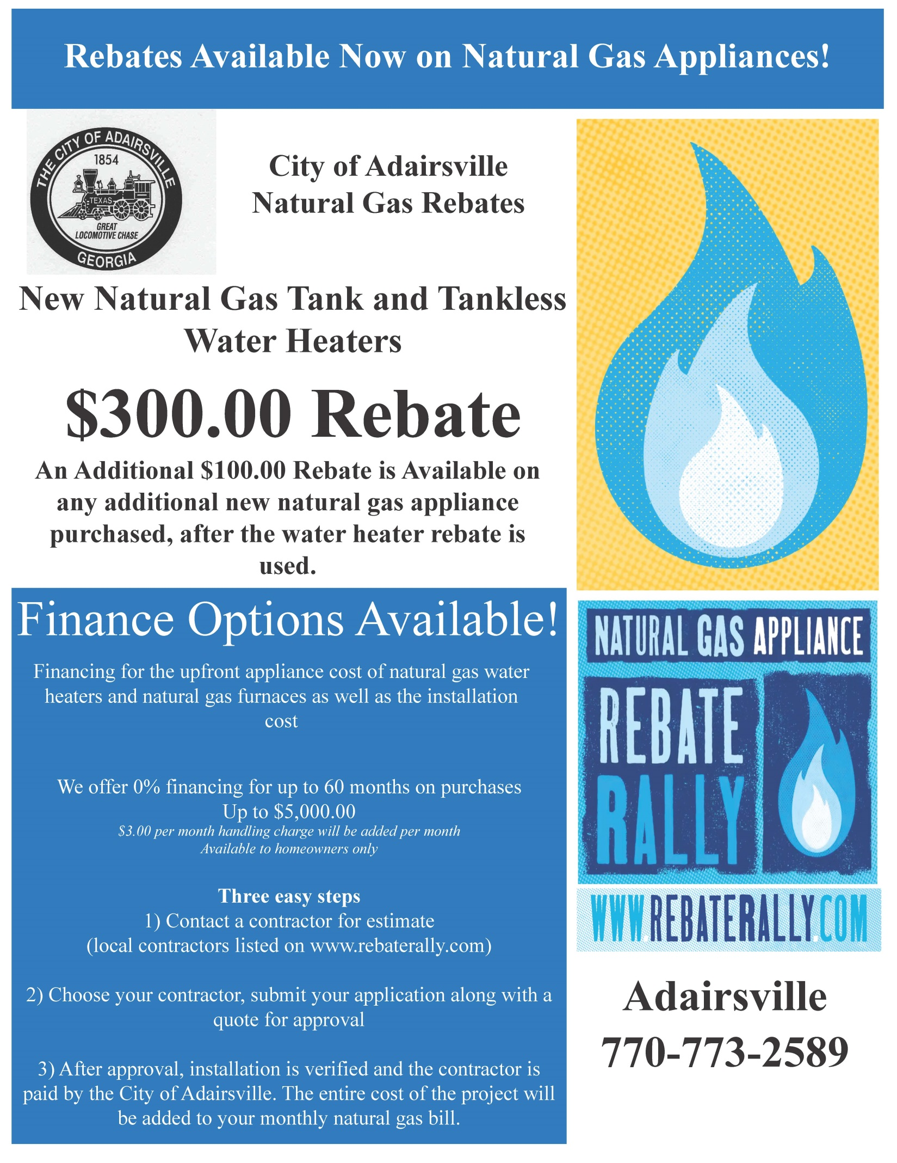
Debris removal by the
City of Adairsville Public Works
For inside City of Adairsville residences

Yard Debris: tree limbs, tree trunks, tree branches or cuttings, shrubs and bushes (not to exceed 8’ feet in length or 6” diameter). – This Does NOT include solid waste, trash or other household garbage, pine straw, grass clippings or stumps.

All leaves MUST be bagged.
Pick up days

Please set yard debris next to the street at least 72-hours prior to scheduled “pick-up” day

January  Every Monday | February  Every Monday | March  Every Monday | April  Every Monday
May  Every Monday | June  Every Monday | July  Every Monday | August  Every Monday
September  Every Monday | October  Every Monday | November  Every Monday | December  Every Monday

No Brush pick up on Holidays/scheduled pickup falls on Holidays will be picked up the next day.

City of Adairsville Residences
Republic Services in cooperation with the City of Adairsville is the City’s trash service provider.
Residential Trash Service
Sign up at the time account is set up
This includes: 1-95 gallon trash container with once a week service

- Pick up will not start before 7:00 a.m.
- Place your cart at least 4’ feet from a mailbox or telephone pole.
- Place your cart at least 5’ feet from a parked car.
- Place your cart within 2’ feet off the roadway.
- Do not place your cart under tree limbs or power lines.
- Place your cart at the street with the handle & wheels facing your home.
- If you have more than one (1) cart, please place them at least 3’ feet apart.
- Carts may be placed on the curb the day before pick up.
- Carts must be removed from the street by midnight on the day of service.

Pick up days every Thursday with the exception of observed holiday weeks where the holiday falls on the regular service day or on a week day prior to the regular service day of Thursday. During those weeks service will be delayed by one day and completed on Friday. Observed holidays are: New Year’s Day, Memorial Day, Independence Day, Labor Day, Thanksgiving Day and Christmas Day.

Residential inside city – Already signed up – Need additional carts; please contact City Hall.
Residential outside city –may call 1-888-235-8503 for availability

CUSTOMER COPY
COPY OF TERMS AND CONDITIONS

1. | I/we, the undersigned, hereby apply for services with the City of Adairsville for the above premises and agree to pay a monthly fee for water / gas supplied which is due within 15 days of being invoiced. The rate, as well as other fees, charges and fines related to water/gas service, is established by resolution of the City Council.  Failure to receive a bill does not relieve customer of liability.
2. | I, the undersigned, hereby understand that I am required to be home at the time city services are scheduled to be turned on. Additionally, I understand that in the event if I fail to comply with the proceeding statement, the city will charge a fee of $20.00 to the bill after the 2nd service call.
3. | A NON-REFUNDABLE 10% LATE FEE is assessed to all accounts that are not paid IN FULL by 5:00p.m. on the 15th of each month
4. | The account shall be subject to termination of services upon non-payment or failure to comply with rules, regulations, ordinances, or laws as established by the City.
5. | Water/gas service shall not be restored after being shut off until ALL money owed, including deposits, fines, fees, and penalties have been PAID IN FULL.
6. | If the utility detects fraudulent or unauthorized service use (and has reasonable grounds to believe the customer is responsible) $150.00 tampering fee for each meter plus cost of materials will be charged and deposit will be increased
7. | There will be a charge on all returned checks in the maximum amount allowed by state law and customer agrees to pay the same.
8. | By requesting services, the applicant agrees to keep current all payments and agrees to pay all costs of collections
9. | Applicant here by warrants and affirms that the information provided in this form is true and correct to the best of his/her knowledge. Applicant also affirms, understands, and agrees to comply with provisions of this utility application for services.
10. | All bills sent to water/gas users shall be deemed to be correct if they are not disputed within sixty (30) days from issuance.
* | Under Georgia law regarding open records is the presumption that all public records are open to the public. Georgia law clearly provides that, except as otherwise specifically provided, “All public records … shall be open for a personal inspection by any citizen of this state at a reasonable time and place; and those in charge of such records shall not refuse this privilege to any citizen.” O.C.G.A. § 50-18- 70(b).

I am at least 18 years of age and I agree with the above terms in the agreement.

